**Business Problem**

**Effective inventory and sales management are critical for optimising profitability in the retail and wholesale industry. Organisation need to ensure they are not incurring losses due to inefficient pricing, poor inventory or vendor dependency. The goal of this analysis is to:**

**-Identify underperforming brands that require promotional or pricing adjustments.**

**-Determine top vendors contributing to sales and gross profit.**

**-Analyse impact of bulk purchasing on unit cost.**

**-Asses inventory turnover to reduce holding cost and improve efficiency.**

**Investigate profitability variance between high-performing and low-performing vendors.**

**Descriptive statistics**

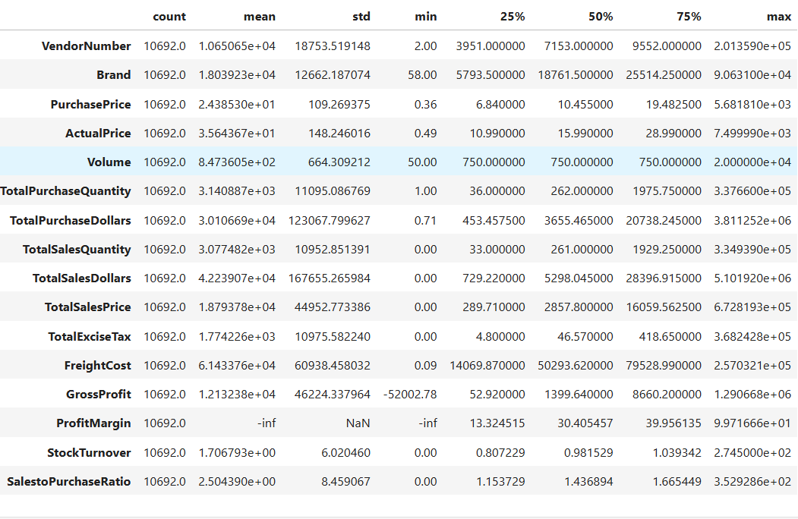

**-On average, vendors generate over 2.5× in sales value compared to their total purchases, showing strong profitability and efficient sales conversion.**

**However, the high standard deviation indicates that a few top-performing vendors drive most of the revenue, while others contribute relatively less — suggesting an opportunity to identify and replicate the practices of high performers**

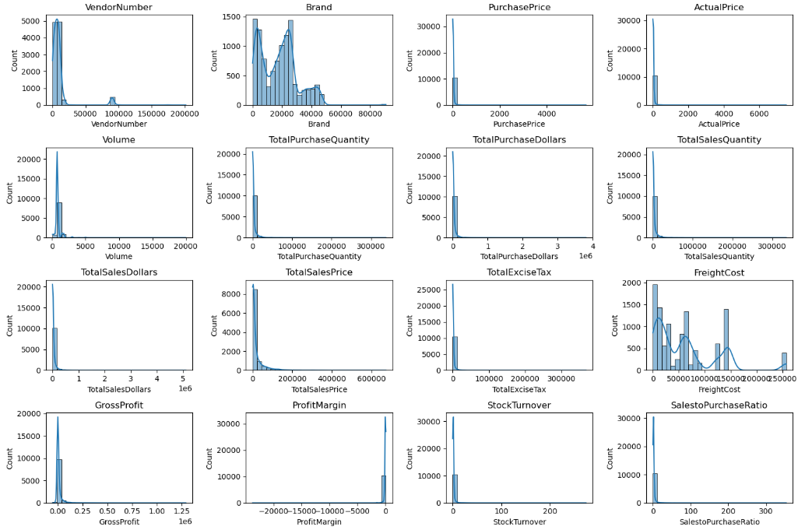

**Negative and Zero Value:**

**1.Gross profit**: **Minimum value is -52,002.78 indicating losses. Some products or transaction may be selling at a loss due to high cost or selling at discounts lower than the purchase price.**

**2.Profit Margin: Has a minimum of -infinity, which suggest cases where revenue is zero or even lower than cost leading to negative profit margins.**

**3.Total Sales Quantity and Sales Dollars**: **Some products show zero sales, indicating they were purchased but never sold. These may be slow-moving or obsolete stock, leading to inventory inefficiencies.**

**Outliers indication by high standard deviation:**

**1.Purchase and actual price**: **The maximum values (5.681.81 & 7.499.99) are significantly higher than the mean (24.39 & 35.64), indicating premium product offerings.**

**2.Freight Cost: Extreme variation from 0.09 to 2.57,032.07 suggest logistics inefficiencies or bulk shipments or erratic shipping costs across different products**.

**3.Stock Turnover: Ranges from 0 to 274.5 implying some product sell extremely fast while other remain in stock indefinitely. Value more than 1 indicates that sold quantity for that product is higher than purchased quantity due to either sales are being fulfilled from older stock.**

**Data filtering**

**To enhance the reliability of the insights, we removed inconsistent data points where :**

**1.Gross Profit <= 0 (to exclude transaction leading to losses).**

**2. Profit Margin <= 0 (to ensure analysis focuses on profitable transaction).**

**3.Total Sales Quantity = 0 (to eliminate inventory that was never sold).**

**Correlation Insights**

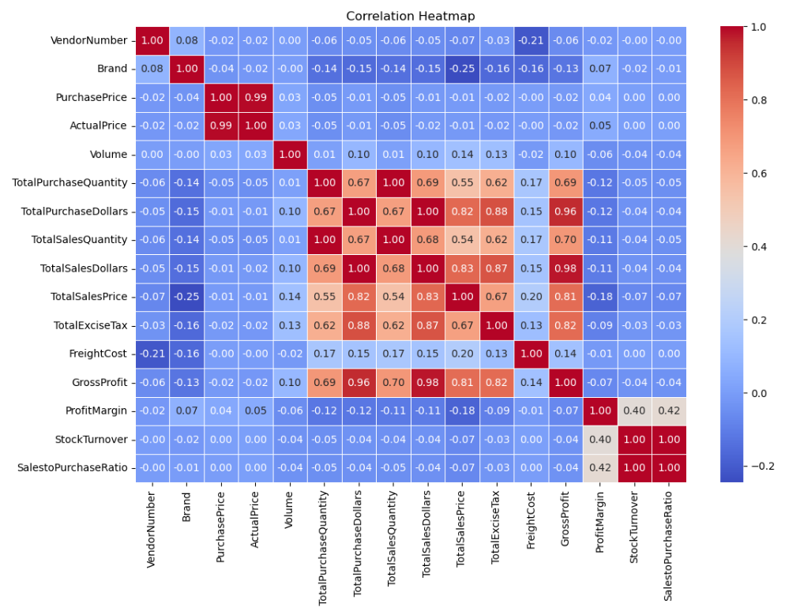

* **Interpretation of Correlation insights:**

**1.Purchase Price vs Total Sales Dollars & Gross Profit: Weak correlation (-0.01 and -0.02), Indicating that price variation do not significantly impact sales revenue or profit.**

**2.Total Purchase Quantity vs Total Sales Quantity**: **Strong correlation (0.999), confirming efficient inventory turnover.**

**3.Profit Margin vs Total Sales Price: Negative correlation (-0.18), suggesting increasing sales price may lead to reduced margins, possibly due to competitive pricing pressures.**

**4.Stock Turnover vs. Gross Profit & Profit Margin**: **Weak negative correlation (-0.04 & 0.40 ), indicating that faster stock turnover does not necessarily equate to higher profitability.**

**Research Questions & Key Findings**

**1.Brands for Promotional or Pricing Adjustments**

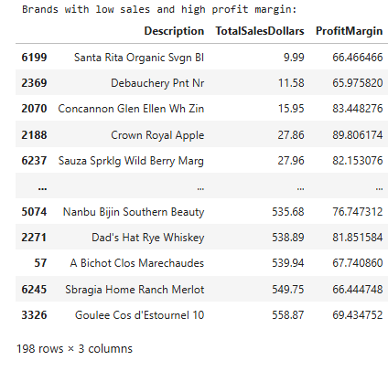

**198 Brands exhibits sales but higher profit margin, which can be increased by promotions, targeted marketing or price optimisations to increase volume without compromising on profitability.**

**1.Brands for Promotional or Pricing Adjustment**

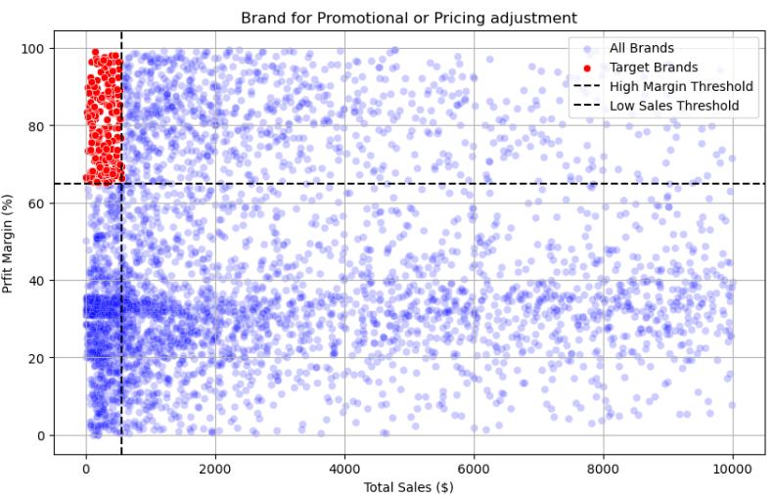

**The scatter plot indicates that several brands (highlighted in red) have high profit margins but low total sales.**

**These brands represent potential targets for promotional or pricing adjustments — by reducing prices or increasing marketing efforts, their sales volume can be improved without severely impacting profitability.**

**Overall, the majority of brands cluster around moderate margins (20–60%) and medium-to-high sales, showing a stable market performance.**

**2. Top Vendors by Sales & Purchase Contribution**

**The top 10 vendors contribute 65.69% of total purchases, while the remaining vendors contribute only 34.31%. This over-reliance on a few vendors may introduce risks such as supply chain disruptions, indicating a need for diversification.**

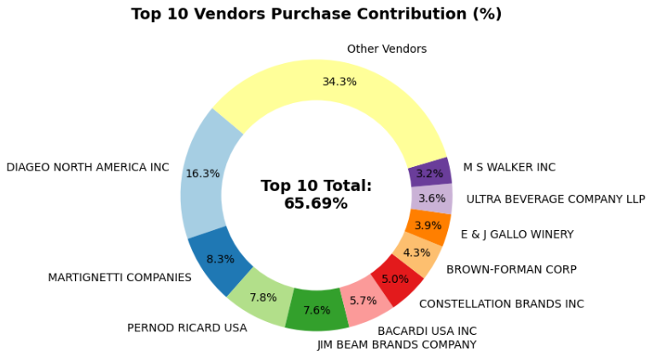

**The purchasing trend suggests strong partnerships with globally recognized beverage brands, reflecting the company’s alignment with premium suppliers; however, diversification into emerging or regional vendors could offer cost optimization and reduce supply risk.**

**3. Effects of bulk purchasing in reducing unit price and optimal purchase volume for cost saving.**

**Vendors buying in large quantities receive a 72% lower unit cost ($10.78) per unit vs. higher unit cost in smaller orders.**

**Bulk pricing strategies encourage larger orders, increasing total sales while maintaining profitability.**

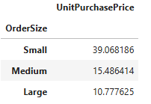

**4. Identifying Vendors with Low Inventory Turnover**

**Total Unsold Inventory Capital: $2.71M**

**Slow-moving inventory increases storage costs, reduce cash flow efficiency, and affects overall profitability.**

**Identifying vendors with low inventory turnover enables better stock management, minimizing financial strain.**

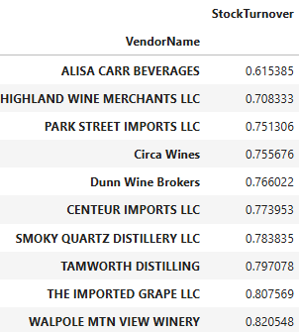

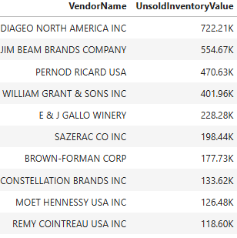

**5.Profit Margin Comparison: High vs. Low-Performing Vendors**

**Top Vendors’ Profit Margin (95% CI): (30.74%, 31.61%), Mean: 31.17%**

**Low Vendors’ Profit Margin (95% CI): (40.48%, 42.62%), Mean: 41.55%**

**Low-Performing Vendors maintain higher margins but struggle with sales volumes, indicating potential pricing inefficiencies or market reach issues.**

**Actionable Insights:**

* **Top-performing vendors: Optimize profitability by adjusting pricing, reducing operational costs, or offering bundled promotions.**
* **Revisit Pricing Strategies: Low-performing vendors with high profit margins should consider revising their pricing to improve competitiveness and boost sales volumes without compromising profitability.**
* **Strengthen Top Vendor Partnerships: Collaborate with top-performing vendors to negotiate better contract terms, such as volume-based discounts or credit benefits, to slightly improve overall profit margins.**
* **Adopt Data-Driven Vendor Segmentation: Categorize vendors into clusters (e.g., “High Volume–Low Margin” and “Low Volume–High Margin”) to apply targeted strategies for improving both sales and profitability.**
* **Benchmark and Share Best Practices: Use operational benchmarks from top-performing vendors to help low-performing ones improve efficiency, pricing discipline, and market competitiveness.**

**Final Recommendations**

**1.Adopt a Data-Driven Decision Framework: Regularly evaluate vendor and brand performance metrics to ensure pricing, inventory, and sales strategies are aligned with business goals.**

**2.Strengthen Supplier Ecosystem: Build long-term relationships with high-performing vendors while onboarding new suppliers to increase competitiveness and reduce operational dependency.**

**3.Enhance Profitability through Product Mix Optimization: Focus on improving the contribution margin by promoting high-performing, fast-moving products and strategically managing low-margin inventory.**

**4.Implement Predictive Inventory Planning: Use historical sales and correlation insights to forecast demand and minimize excess stock or stockouts, improving overall supply chain responsiveness.**

**5.Invest in Brand and Channel Diversification: Expand marketing efforts and sales channels (online and offline) to capture untapped customer segments and stabilize revenue streams.**

**6.Monitor and Review Performance Continuously:**

**Establish a performance review system (monthly or quarterly) to track progress, identify inefficiencies, and adjust strategies proactively.**